Clinical Educator Programme

“USING TECHNOLOGY

in your TEACHING”

Worksheets for ‘taster’ technologies:

1. Uploading and making videos with ‘Media Hopper’
2. Inserting Videos into PowerPoint
3. Voting with ‘Top Hat’
4. Using the ‘virtual classroom’

Uploading and making videos with ‘Media Hopper’

** Ensure you use Internet Explorer from “Desktop” mode on the tablets during the taster session

Navigate to http://media.ed.ac.uk then click on the Guest button and finally the Login button.

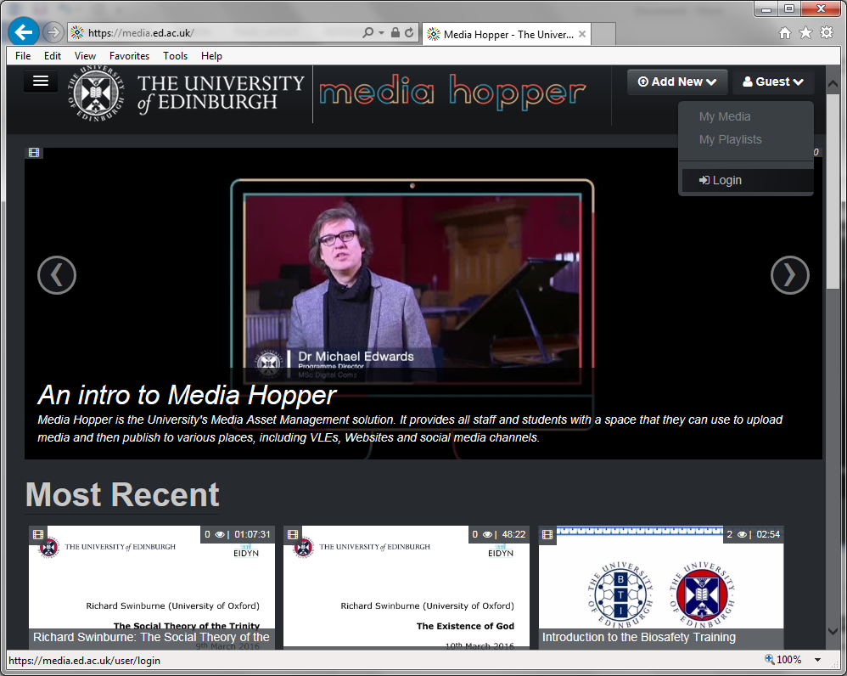

This will take you to the EASE login page where you will enter your UUN (Universal Username) and associated password. After logging in to EASE, you will automatically be taken back to the Media Hopper page.

1. Uploading Media

Click the Add New button and then choose one of the options from the drop down list. For the purposes of this session, choose Media Upload.

Click the + Choose a file to upload button, navigate to the Videos folder on the Desktop and select the CEP_UTT_Test.mp4 video file. (Note: This video file has no sound.)
After the upload is complete, you will be asked to fill out some relevant information for the video. Please be aware that in order to publish the video, you must complete all of the marked fields. For the purposes of this activity, complete the fields as follows:

Name: Test Video for CEP UTT
Description: Test Video for CEP UTT
Tags: Test and CEP
Course Code: {leave blank}
Publisher: {leave blank}
Licence Type: All rights reserved The University of Edinburgh
Language: English
Date Created: {leave blank}
Scheduling: Any Time
** Leave the last entry as Private so that access rights for the video remain with just you.

Click the Save button and then once the message Media successfully set to Private appears, click the Published button, click Publish in Channel then tick the box for CEP UTT and finally click the Save button.

You can now check the media by clicking on the Go To Media button.

2. Creating New Media

Click the Add New button and then choose Launch Desktop Recorder. If you receive a warning message (titled External Protocol Request) asking if you want to allow the website to launch a program on your computer, ensure you allow it.

** If you’ve never used the desktop recorder before, you may be asked to install the software first (there are installers for both PC and Apple Mac). Click on the download link for the appropriate version of the software and follow the on screen instructions. For this session, the software has already been installed.

A new window will appear with several buttons (Presentations & Lectures, Screen, Screen & Webcam, Webcam and Voice). Details of the different options can be found on page 4 of the following document http://www.docs.is.ed.ac.uk/skills/documents/Media%20Hopper/3841.pdf. For the purposes of this session, click on Screen. If your computer has multiple screens, you will be asked which screen you wish to capture from. You will also be asked if you wish to capture the full screen or a selected area. Choose one of the options and then when you’re ready to create your media, click on the Record button.

You will receive a 5 second countdown and then the software will start capturing your screen and microphone (if one is attached). Perform a few functions on the screen, such as opening a web page and navigating to a couple of sites. State what you’re doing briefly, so that the microphone captures the audio as well.

Once you’re happy with what you want to capture, click on the multi-coloured sun burst icon in the Windows task bar to open the Recording Screen Capture application and then click Done. The software will generate the video and start playing it back for you to review. There are some basic editing tools on the left but for the purposes of this session just click the Done button. You will be asked to give the media a Title and you can also enter a description and some tags (tags are words that can be used in the search function to find your video). Once you’ve entered the relevant information, click the Upload button. Once the upload is complete, click on the link displayed to go to your My Media folder. After a few seconds the new media should appear at the top of the page. It will initially be set to Private so if you wish you can edit the information and then publish it as you did when uploading content.

** You can access your media files at any point by clicking on your name in the top right corner and then clicking on My Media.

3. Discuss and evaluate

We will now discuss together when and how you might want to use Media Hopper. We will also think about its limitations and any reservations you have about using it.

………………………………………………………………………………………………………………………

4. Further information about similar tools:

Jing – https://www.techsmith.com/jing.html

Jing is a FREE screenshot and screencast tool which allows you to record up to 5 minutes of video and audio.

Adobe Presenter - http://www.adobe.com/uk/products/presenter.html

Adobe Presenter allows you to simultaneously capture audio and your PowerPoint presentation. If you have a Universal Username (University of Edinburgh UUN), you can use Adobe Presenter version 7 for FREE from your University owned computer/laptop as the University of Edinburgh have a site license for its use. You will need to email Alan Gilchrist at A.Gilchrist@ed.ac.uk who will arrange a time to install it on your computer.

You can also use Version 9 for FREE, however you will need to arrange to come in to the Learning Teaching and Web Division in the Hugh Robson building on George Square to make your recording there.

VoiceThread - http://voicethread.com

Voice Thread is another similar tool. It is currently not free.

Inserting Videos into PowerPoint

It can be extremely helpful to use video clips in your teaching, eg by inserting a local video file or a link to a clip from YouTube into a PowerPoint presentation. There is a huge amount of video footage available on the internet on a wide variety of subjects, (and of varying quality of course!). Once you know what topic you are looking for, you can search a number of sources for suitable material. Media Hopper is set to become the location for almost all of the University’s media content, however there are other sources available to University members such as Box of Broadcasts.

1. Inserting local video file

Open PowerPoint by double clicking on the PowerPoint shortcut on the desktop. Click the Insert button at the top, then Video on the right and finally Video on My PC… Navigate to the Videos folder on the Desktop, select the CEP_UTT_Test.mp4 video file and click Insert. Start the slide show and then move the cursor over the video and click the Play button. Press the Esc key at any point to come out of the slide show.

If you would like the video to start playing as soon as you reach the particular slide, click once on the video and then click the Playback button at the top. In the Video Options section, change Start: On Click to Automatically. Notice the other options you can select within the Video Options section.

2. Inserting link to Media Hopper content

Log in to Media Hopper and then go to My Media (click on your name in the top right corner then choose My Media). Click on the image of one of your videos and then click the Share button. Copy the text in the Link to Media Page by holding down the Ctrl key and pressing C.

Open PowerPoint, click the Insert button at the top and then click on Text Box. Click on the slide where you would like the text box to begin and then paste the link to the Media Hopper video by holding down the Ctrl key and pressing V. Press Enter to turn the text into a hyperlink and then start the slide show. Move the cursor over the hyperlink text and click the mouse button. If you’re logged into Media Hopper with the default web browser (on the tablets this is Internet Explorer) you will be taken straight to your video. If you aren’t already logged in to Media Hopper, you will be asked to log in and then be taken to the video.

3. Discuss and evaluate

We will now discuss together when and how you might want to use videos in PowerPoint. We will also think about its limitations and any reservations you have about using it.

………………………………………………………………………………………………………………

4. Further suggestions:

If you have time, you could browse some other websites for useful materials:

- Box of Broadcasts – http://bobnational.net
Box of Broadcasts is a facility which is FREE for all University of Edinburgh staff. It can be used to create clips from any terrestrial TV programme.

- TED - http://www.ted.com
- YouTube UoE channel- http://www.youtube.com/user/EdinburghUniversity
- Khan Academy - http://www.khanacademy.org

Suggestions for using these clips within EEMeC or other websites include:

- Downloading as a podcast
- Downloading as an MP3 or MP4
- Embedding the clip in a web page

- Voting with ‘Top Hat’

Navigate to https://app.tophat.com and in the Search for a school box start typing Edinburgh. Select University of Edinburgh when it appears and click on the Login button.
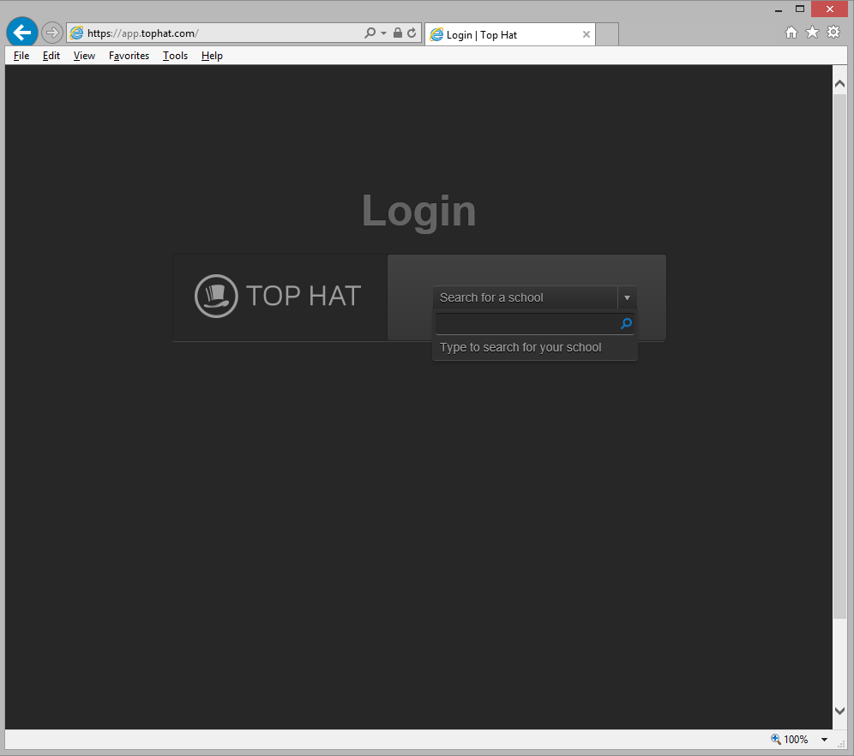

This will take you to the EASE login page where you will enter your UUN (Universal Username) and associated password. After logging in to EASE, you will automatically be taken back to the Top Hat page.

** The first time you log in to Top Hat you will need to set up your account as a ‘Professor’ but for the purposes of this session this has already been carried out. You can find full instructions for account creation at http://www.ed.ac.uk/files/atoms/files//creating_a_top_hat_professor_account.pdf.

Click the Enter Course button next to CEP UTT to open the course content page. After the page loads, click the Settings button in the top right (picture of a cog) and then click on Course Settings. Click on the Grading Options button on the left, then under the Question Defaults change the Default Correctness Mark to 1 and the Default Participation Mark to 0 and click Save. Click on the Advanced Options button and then tick the box labelled New report session on activation and click Save (this will store the student responses for each session separately). Click on the Content heading at the top of the page to go back to the initial course content page.

Creating questions

To start creating questions, click on the Create button below the Content heading and then select Question. You will be given a choice of 6 question types. In this first instance, select Multiple Choice. Fill out the relevant fields for your first question and then click the Save button.

** Title is the reference you use for the specific question so that you can quickly identify it.

Create a second question, this time select the Word Answer and click Next. Fill out the relevant fields and then click the Save button. If you don’t want the question to have a correct answer, click the X next to the Correct Answer field. If it should have a correct answer, add the correct responses in the Correct Answer fields (you can enter multiple correct responses by using the Add button if you’re expecting more than one correct answer). Unless case is a requirement, you should leave the Response Option as Case insensitive.

Asking questions

There are a few ways to ask questions, but in this session we will just outline the process to ask questions directly through the web page. Click on the first question you wish to ask from the list on the left side of the screen and then click the Present button in the top right corner. This will show the course Join Code on the screen, so that students can enroll on the course. Once you’re happy students have enrolled on the course, click the Start Presentation button. This will activate the first question and push it out to the enrolled students. As students respond, the counter at the bottom will increase. When you’re ready to move on to the next question, click the Show Responses button (picture of a bar chart). This will stop students from being able to respond to the question and display the response on screen. Click the Right Arrow in the bottom left corner to move onto the next question which will automatically be activated and pushed out to the students. Once you’ve reached the end of your questions, click the Up Arrow button in the bottom left corner then click End Presentation.

You will be taken back to the course content page, where if you wish, you can review the responses again. If you wish to review responses to the individual questions from different sessions, click on the All results button in the centre of the screen and then choose which session you wish to review.

Other options for asking questions involve uploading your PowerPoint presentation into Top Hat and then adding questions between slides, or using the Top Hat Presentation Tool in conjunction with PowerPoint or similar presentation software. Information on these options can be found in the Top Hat Media Hopper Channel:

https://media.ed.ac.uk/channel/Top+Hat+Videos

3. Discuss and evaluate

We will now discuss together when and how you might want to use Top Hat. We will also think about its limitations and any reservations you have about using it.

……………………………………………………………………………………………………………………

4. Further information about similar tools:

If you have time, take a look at some of the other tools that you might use:

Tools for use outwith the classroom:

Survey Monkey - https://www.surveymonkey.co.uk/

Bristol Online Survey (BOS) - http://www.survey.bris.ac.uk/

This tool is similar to Survey Monkey but it is more sophisticated. It allows you to create and run online surveys, analyse the results and transfer the data to other packages such as Excel. If you have a Universal Username (University of Edinburgh UUN), you can use BOS for FREE as the University of Edinburgh have purchased a license for its use. Go to http://www.ed.ac.uk/schools-departments/information-services/learning-technology/survey-tools/bristol-online-survey/using This website will tell you what to do. You will need to contact IS.Helpline@ed.ac.uk

Google - http://google.about.com/od/toolsfortheoffice/ss/forms_googledoc.htm

You can create surveys and quizzes for FREE using Google Docs.

Using a Virtual Classroom

A virtual classroom refers to a single ‘space’ where a number of participants can come together online and interact with one another via voice, video and the written word. Documents and other files can also be uploaded to facilitate discussion and the sharing of ideas.

Blackboard Collaborate

Blackboard Collaborate is the University of Edinburgh’s centrally supported ‘virtual classroom’:

Collaborate: http://www.ed.ac.uk/schools-departments/information-services/services/learning-technology/communication/collaborate/preparing

1. Prepare your machine

Access the web page above to prepare your computer for Collaborate.

Follow ‘Step 2’ on the screen. This ensures your computer has the operating system it needs. You will need to run Java.

Follow ‘Step 3’ on the screen. This gets your computer to set up ‘Blackboard Collaborate’ and makes sure its microphone and speakers are working properly.

Create a Collaborate Session via MyED

Log in at www.myed.ed.ac.uk. Access Collaborate from the Services menu.

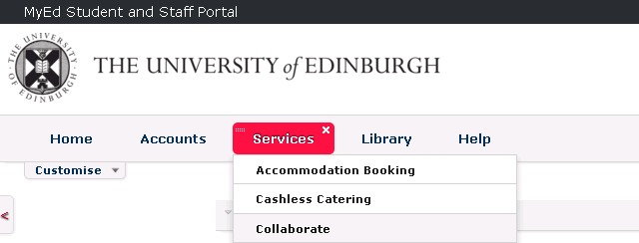

Click on ‘Schedule Session’. This will bring up a form similar to that shown on the next page.

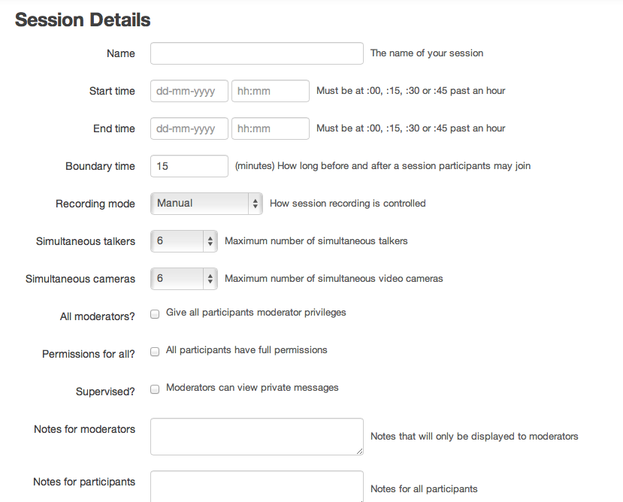

Invite people to attend the tutorial. If they have university email addresses, you can make them Moderators or Participants. If they don’t have a university email addresses, enter their email address under External Participants. Everyone invited should receive a link straight to the online session in their inbox which will tell them what to do.

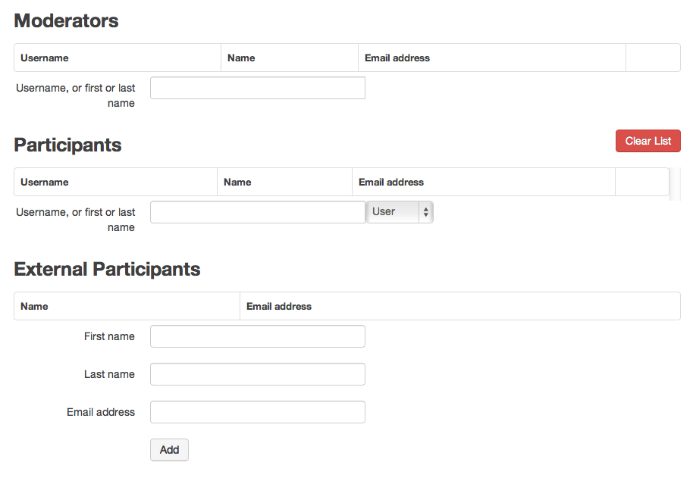

3. Further information about Collaborate:

For further information and an overview of Collaborate, have a look at:

http://www.ed.ac.uk/schools-departments/information-services/services/learning-technology/communication/collaborate/overview

4. Further information about similar tools:

Adobe Connect - http://www.adobe.com/uk/products/adobeconnect.html

Adobe Connect is similar to Collaborate. Since everyone attending the Clinical Educator Programme (CEP) workshops is involved in the teaching of University of Edinburgh students, all are eligible to access Adobe Connect for FREE, as the College of Medicine and Veterinary Medicine has purchased a license for its use. You will need to email Alan Gilchrist at A.Gilchrist@ed.ac.uk who will create an account for you in the ‘Waverley Suite’.

“Using Technology in Your Teaching”: Useful Contacts

Getting started:
- Everyone needs to have a University of Edinburgh ‘Universal Username’ (UUN) to access most of the tools in this workshop for free. Since everyone attending the Clinical Educator Programme (CEP) workshops is involved in the teaching of University of Edinburgh students, all are eligible for a UUN. You can register for a UUN by emailing cep@ed.ac.uk.
- A UUN allows you to use the University’s central portal, which is called ‘MyEd’.
- The University of Edinburgh medical school operates an electronic medical curriculum (EEMeC). All CEP workshop attendees are eligible for access. You can register by emailing eemec@ed.ac.uk and briefly explaining your teaching role.

Recording your own materials (eg to put your videos/lectures online)
- Technical Support (Media Hopper): IS.Helpline@ed.ac.uk; A.Gilchrist@ed.ac.uk
- Technical support (Adobe Presenter): A.Gilchrist@ed.ac.uk
- Educational support: Jo.Spiller@ed.ac.uk or Debbie.Aitken@ed.ac.uk

Embedding your/other materials into PowerPoint
- Technical support: IS Skills is.skills@ed.ac.uk
http://www.ed.ac.uk/schools-departments/information-services/services/help-consultancy/is-skills/catalogue/catalogue-subject/catalogue-presentation
- Educational support: Debbie.Aitken@ed.ac.uk

Using online surveys
- Bristol Online Survey
  - Technical support: IS.Helpline@ed.ac.uk; A.Gilchrist@ed.ac.uk
  - Educational support: Debbie.Aitken@ed.ac.uk; Jo.Spiller@ed.ac.uk
- Survey Monkey (NHS Fife)
  - Technical support: ann.sheach@nhs.net; Elspeth.dowling@nhs.net
  - Educational support: Debbie.Aitken@ed.ac.uk

Using ‘live’ polls and voting
- Top Hat:
  - Technical support: IS.Helpline@ed.ac.uk; A.Gilchrist@ed.ac.uk
  - Educational support: Jo.Spiller@ed.ac.uk; Debbie.Aitken@ed.ac.uk
- Turning Point clickers (Fife):
  - Technical support: ann.sheach@nhs.net; Elspeth.dowling@nhs.net
  - Educational support: Debbie.Aitken@ed.ac.uk

Setting up and using a virtual classroom
- BlackBoard Collaborate Virtual Classroom
  - Technical support: IS.Helpline@ed.ac.uk; A.Gilchrist@ed.ac.uk
  - Educational support: Debbie.Aitken@ed.ac.uk; Jo.Spiller@ed.ac.uk

Advice about, (and having a practice ‘go’ on) a SMART board
- Clinical Skills Centre, all Seminar Rooms in Chancellor’s Building, Greenfield Suite (Teviot) and A & E teaching room, RIE (NHS Lothian/University)
  - Technical support: A.Gilchrist@ed.ac.uk
  - Educational support: A.Gilchrist@ed.ac.uk; Debbie.Aitken@ed.ac.uk
- Education Centre VHK (Fife):
  - Technical support: ann.sheach@nhs.net; Elspeth.dowling@nhs.net
  - Educational support: Debbie.Aitken@ed.ac.uk

Other: eg using PACS, SMOTS, Sim man
- Clinical Skills Centre and Clinical Skills Ward (NHS Lothian/University)
- Technical support: A.Gilchrist@ed.ac.uk
- Educational support: A.Gilchrist@ed.ac.uk
- NHS Fife
  - Technical support: TBC
  - Educational support: bshippey@nhs.net

Information governance
NHS Lothian
- TBC

NHS Fife
- Una Hill
- Consultants Mandatory Training programmes (each Consultant/SAS must attend once a year): Run by the Medical Directorate Office.

Finding out more about what’s available where you are:
South East Scotland
Debbie.Aitken@ed.ac.uk

Fife
www.nhsfife.org/medicaleducation

